Take Apart Activity
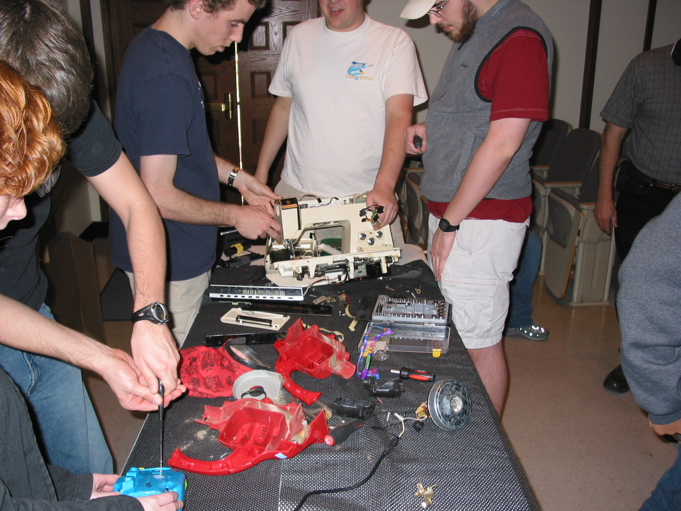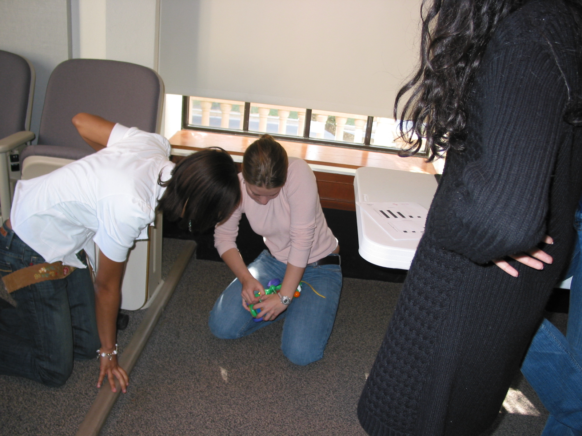
Purpose: This activity is designed to engage students in the engineering process. By taking apart, or reverse engineering, a simple device (Polly Pocket Fountain Falls), students can see why certain components are needed and how those components address certain constraints.
*Materials: 10 simple devices (e.g. toys, tape recorders, water pumps…etc)
10 tool sets (for Polly Pocket only screwdrivers are needed)
Enough protective covering to lay atop desk surfaces.
Conducting the Activity: 1. Before beginning the activity, have protective covering laid across the students’ desk tops. 2. Distribute devices so that there are about three students per device. 3. Pass out tool sets. 4. Commence taking apart the devices. 5. At the end of the activity have students bring up and present any interesting findings/components to the class. If there is extra time challenge students to put it back together!
*Quantities are for classes of size 30

